**NIAHO® Accreditation**

--------------------------------------------------

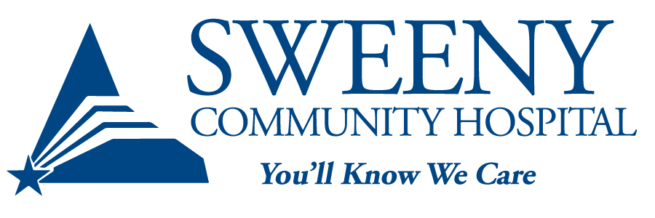

For: Sweeny Community Hospital

Kari Schroeter, 979.548.1877

KSchroeter@SweenyHospital.org

For: DNV

Randi Michael

513-313-0790

Randi.michael@dnv.com

**SCH RECEIVES NEW QUALITY-BASED ACCREDITATION FROM DNV**

Sweeny, TX — Sweeny Community Hospital announces the successful completion of its new accreditation process from has been awarded by [DNV](http://www.dnvcert.com/healthcare).

By earning accreditation, SCH has demonstrated it meets or exceeds patient safety standards (Conditions of Participation) set forth by the U.S. Centers for Medicare and Medicaid Services. DNV’s accreditation program is the only one to integrate the ISO 9001 Quality Management System with the Medicare Conditions of Participation.

“The DNV program is consistent with our long-term commitment to quality, patient safety, and our community,” says Kelly Park, CEO. “The ability to integrate ISO 9001 quality standards with our clinical and financial processes is a major step forward.”

SCH has three years from the date of its accreditation to achieve compliance with ISO 9001, the world’s most trusted quality management system used by performance-driven organizations around the world to advance their quality and sustainability objectives.

“We have taken an entirely different approach to accreditation, and hospitals are really responding,” says DNV Healthcare USA Inc. President Kelly Proctor. “Since accreditation is a must-have credential for just about every hospital in this country, why not make it more valuable, and get more out of it? That’s where ISO 9001 comes into play and turns the typical get-your-ticket-punched accreditation exercise into a quality transformation.”

DNV’s accreditation program, called NIAHO® (Integrated Accreditation of Healthcare Organizations), involves annual hospital surveys – instead of every three years – and encourages hospitals to openly share information across departments and to discover improvements in clinical workflows and safety protocols.

**About DNV**

DNV is a global independent certification, assurance and risk management provider, operating in more than 100 countries. Through its broad experience and deep expertise, DNV advances safety and sustainable performance, sets industry benchmarks, drives innovative solutions.

Whether certifying a company’s management system or products, accrediting hospitals, providing training, assessing supply chains or digital assets, DNV enables customers and stakeholders to make critical decisions with confidence, continually improve and realize long-term strategic goals sustainably.

DNV draws on its wide technical and industry expertise to help companies worldwide build consumer and stakeholder trust. Driven by its purpose, to safeguard life, property, and the environment, DNV helps tackle the challenges and global transformations facing its customers and the world today and is a trusted voice for many of the world’s most successful and forward-thinking companies.

For more information about DNV, visit [www.dnvcert.com/healthcare](http://www.dnvcert.com/healthcare)

# # #